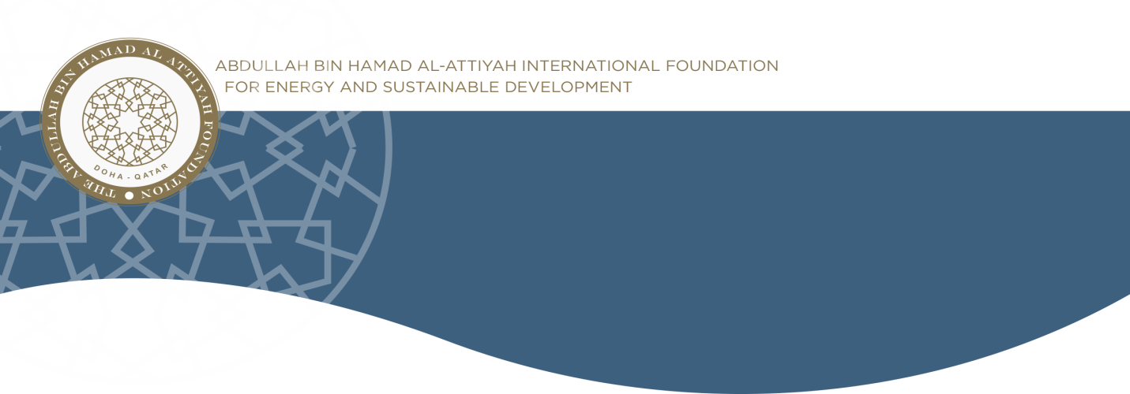

**Monthly Sustainability Newsletter**

***March 2017, Vol. 1, Issue 2***

**CHAIRMAN’S MESSAGE**

# Upcoming Events

**May.** 5th Annual Energy Awards.

**May.** CEO Roundtable Series 4.

**Sep.** CEO Roundtable Series 5.

**Dec.** CEO Roundtable Series 6.

|  |
| --- |
|  |
| Important Announcement *\* * \**  **5th Annual Energy Awards**  The Abdullah Bin Hamad Al-Attiyah International Energy Awards are celebrating their 5th Anniversary in 2017, and in commemoration of this special occasion a one day forum will be produced in alignment with the annual awards to gather all the former winners and relevant stakeholders for an international brainstorming conference.  *Date: May 08th*  **The 1st Forum of Energy Elders**  *Date: May 09th*  *\* * \**  **CEO Roundtable Series 5**  The Implications of the Paris Agreement for Oil and Gas Companies in Qatar  *Date: 12th September 2017* |

|  |
| --- |
|  |
| Dear members, partners, friends and stakeholders. It is my pleasure to introduce the second issue of the monthly Newsletter from the Abdullah Bin Hamad Al-Attiyah International Foundation. In this month’s publication, we look at carbon footprint, carbon neutral initiatives and progression towards the 2 degrees Celsius global goal.  When 196 countries - Parties to the United Nations Framework Convention on Climate Change (UNFCCC) - adopted the Paris Agreement in December 2015, it represented a major breakthrough. After more than 20 years of negotiations, the world agreed on a blueprint on how to keep global climate change well below 2 degrees Celsius. The agreement is seen by many world leaders that gathered in Paris in December 2015, as the last hope for humanity to preserve the foundations for a healthy planet.  The focus in the climate change world is now shifting from negotiating an agreement to implementing action on the ground. Under the Paris Agreement, each country has to set forth a climate action plan (a Nationally Determined Contribution – NDC), which describes the targets of the country, and the means for reaching the target. These NDCs are now front and center of the attention by any sector, company and organization, wishing to understand what role they can play, and how they will be impacted by the new climate policies. While these NDCs are “living plans” in that they are expected to be regularly updated, they all have the 2 degrees Celsius target in common, as their ultimate objective. In this month’s Newsletter, we explore who is doing what, through carbon neutral initiatives, as contributions to global effort to achieve the 2 degrees Celsius goal. |
|  |

**THIS MONTH’S NEWS AT A GLANCE**

**Carbon Footprint / Carbon Neutral initiatives:** Assessments and paths.

**Who is doing what?** The progress of organizations and countries.

**What are Individuals doing?** Individual efforts towards carbon neutrality.

**What are Companies doing?** Companies efforts towards carbon neutrality.

**What are Countries doing?** Global efforts towards carbon neutrality.

**Key Drivers for going Carbon Neutral:** Major Impacts towards Goals

**Carbon Footprint / Carbon Neutral initiatives**



|  |
| --- |
|  |
| Carbon Neutral Countries  Carbon Neutral Companies   *Source: Wikipidia.org* |

Science tells us clearly that in order to maintain climate change below 2 degrees C, the planet has to become climate neutral in the second half of this century. This means that the emissions of greenhouse gases must not exceed what is naturally absorbed in so called “carbon sinks”, such as forest and oceans. Today we are emitting some 50 billion tonnes of greenhouse gas emissions in total, above and beyond what existing carbon sinks can absorb. The challenge is to bring these emissions down to zero in this century and/or to increase the carbon sinks so that they can absorb the remaining emissions.

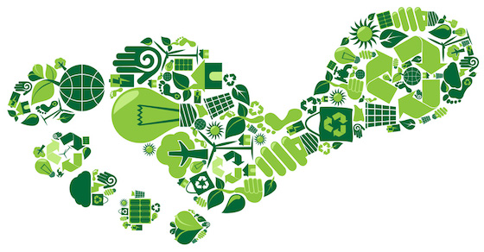Most greenhouse gas emissions are related to burning of fossil fuels, for heating, transport, industrial production or electricity generation, but also emissions from agriculture, waste dumps or leakage from coal mining and air conditioning are significant sources. All these activities contribute in different ways to meeting the needs of our modern society. The climate challenge, of course does not mean that we limit or reduce our social needs, but it means that we need to achieve these activities in a less polluting way. Governments will need to rethink what policy signals they send (for example, replacing fossil fuel subsidies with renewable energy support), companies have to consider new production methods to reduce their climate footprint, and individuals can consider how their daily choices can help reduce their climate footprint. Across the entire spectrum of actors, it is clear that the cost of increased greenhouse gas emissions need to become accounted for rather than being seen as a free resource, as is still often the case.

**Who is doing what?**

It is with this background that more and more companies, organizations and individuals are taking action to move towards becoming climate neutral. The climate change secretariat (the secretariat to UNFCCC) has for the past several years promoted climate neutrality through its Climate Neutral Now initiative (www.climateneutralnow.org), encouraging both companies and individuals to take action.

*(Source: http://www.climateneutralnow.org)*



|  |
| --- |
|  |
| **World’s Largest CO2 Emitting Countries**    *Source: Wikipidia.org* |

**What are Individuals doing?**

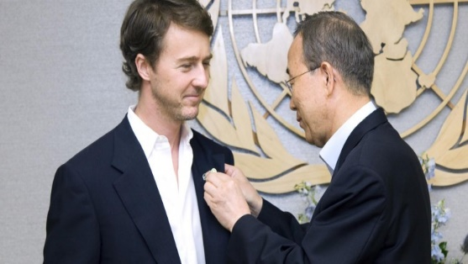**The UNFCCC Climate Neutral Now Initiative offers, through its website (www.climateneutralnow.org), an on-line climate footprint calculator where individuals can calculate their climate footprint. Once one has found out how much emissions the different activities in their life generate, they can take action to reduce them. Generally, it is not possible to completely eliminate an individual’s emissions. In these cases, people may choose to instead compensate their remaining climate footprint by using offsets. Climate Neutral Now also provides an on-line platform where people can immediately select, purchase and cancel offsets that are certified by the United Nations (www.offset.climateneutralnow.org). Several well-known personalities such as movie star Edward Norton, fashion designer Vivienne Westwood, and singer Angelique Kidjo are all climate neutral champions. *(www.climateneutralnow.org)*

**What are Companies doing?**

There are also an increasing number of companies and organizations committing to climate neutrality. Among well-known brand names are Microsoft, Sony, Marks & Spencer, Aviva, FIFA and the 68 organizations making up the United Nations system. Each of these organizations and companies have developed their own plans and approaches for how to reduce their climate footprint. Most of them include three steps:

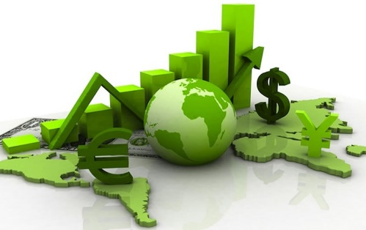**1) Measure/calculate the climate footprint.** Only by having a proper inventory of the greenhouse generated from it’s activities, can a company identify emisions reduction options.

**2) Reduce emissions as much as possible.** This may entail shifting energy sources, using new technologies or improving efficiencies in work.

**3) For emissions that the company can’t reduce, it can make investments in external emission reduction projects.** Many companies and organizations chose to use UN certified emission reduction units (offsets) from the Clean Development Mechanism (CDM) while others invest in emission reduction projects*.*

*(Source:* *http://www.unsystem.org***)**



|  |
| --- |
|  |
| Offset Market   *100 million Tonnes of CO2 emissions are cut each year on the voluntary carbon offset market.* Cost of Carbon Credits   Carbon credits vary around $2.52 per tonne in the voluntary carbon trading market.  *Source.climateneutralnow.org* |

**What are countries doing?**

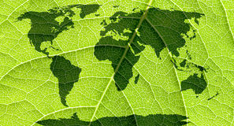Climate neutrality, however, goes beyond, individuals, companies and organizations. Also subnational authorities and even countries are engaged in this work. The Carbon Neutral Cities Alliance, launched in 2014, includes metropolises such as Berlin, London, Melbourne, Oslo, and San Francisco, that have committed to integrate climate neutrality in all aspects of planning, infrastructure development, and in support to innovation (www.usdn.org/public/page/13/CNCA). The island prefecture of Jeju in South Korea has adopted a plan to make the entire region self-sufficient with renewable energy by 2030. This is matched by Germany’s ambition to fully decarbonize its transport system, including banning sales of fossil fueled vehicle from 2030. Sweden recently adopted a law requiring the entire country to become climate neutral by 2045, and Finland has launched the Citizens’ Climate Pledge” – an initiative to systematically encourage and support citizens to reduce their climate footprint and eventually go climate neutral. Major sports events, such as the Rio Olympics and FIFA Football World Cup are examples of climate neutral events. Indeed, the list of initiatives and actions, all moving towards the common goal of climate neutrality can be made very long, and it is increasing every day. *(Source: www.usdn.org)*

**Key Drivers for going Carbon Neutral**

The massive wave of climate action by citizens, companies, organizations, cities and countries is an encouraging and appropriate response to the climate change challenge, but is in fact driven by something in addition to the political consensus that the Paris Agreement represent. Indeed, the Paris Agreement sends a signal that climate friendly action is the “smart thing to do”, because governments are now fully committed to enact policies and legislation that will give climate smart companies and organizations an advantage. However, additional drivers such as wastage of energy, resources and costs, the liability of a cliamte foorprint that will continue to grow and cusumer awareness of the climate impact of products are all key driver for carbon neautrality.

|  |  |
| --- | --- |
| **Journal Reference**  Who is doing what? www.climateneutralnow.org  What are Individuals doing? www.climateneutral.org  What are Companies doing? www.unsystem.org  What are Countries doing? www.usdn.org | **Information**  E-mail: [Sustainability@abhafoundation.org](mailto:Sustainability@abhafoundation.org)  www.abhafoundation.org |